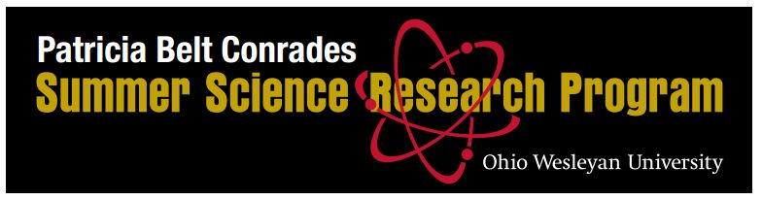

**2022 Student Application Form**

Submission Deadline: 17 February 2022

**Student name:** ___________________________________ Graduating Class: 20____

Email: [____________________@owu.edu](mailto:____________________@owu.edu)

Major(s): _____________________________ Minor(s): _______________________

Overall GPA: _________________ GPA in Major(s): _________________

**First Choice Project:** _____________________________________________

Mentor name: ______________________________________________

**Second Choice Project:** ___________________________________________

Mentor name: ______________________________________________

**Letters of recommendation were requested from:** (A recommendation from the mentor of your preferred project is strongly suggested.)

1._______________________________ 2. ____________________________

**Describe how your previous coursework and experience meet the qualifications of this project.**

**Describe how you believe this summer experience will influence your undergraduate experience and career plans.**

**What other experiences, if any, have you had similar to the OWU Summer Science Research Program?**

**Submit your application**

*Please save this application as a* ***pdf*** *and send it to ssrp@owu.edu by 17 February 2022 with the subject line “Application for* student’s name*.” Also, arrange to have your academic transcript and two letters of recommendation sent electronically to* [*ssrp@owu.edu*](mailto:ssrp@owu.edu)*. Please use the Transcript Release Form so that the Registrar can release your transcript to SSRP. Unofficial transcripts submitted directly by students will not be accepted. (Transcript Release forms can be found at ssrp.owu.edu )*

The committee will make placements based on, among other factors, the following criteria: a student’s preference, year of study, GPA overall and in major, course preparation for the internship, previous research experience, personal statement and career goals, and faculty evaluations. The committee will attempt to support as many students and projects as available funds permit and will attempt to balance these awards across eligible departments based on the general merit and experience that these projects will provide to qualified students.