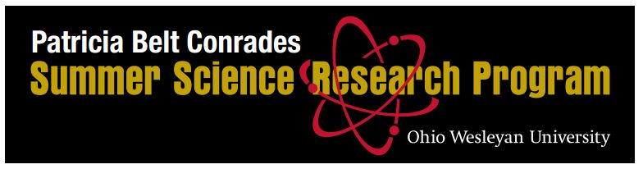

**2022 Faculty Recommendation Form**

Submission Deadline: 17 February 2022

**Student name:** _______________________________________

**Faculty Name:** ______________________________Is this student applying for your project? _____

Overall Evaluation: 1 2 3 4 5 6 7

Not Recommended Highly recommended

**Please provide a narrative evaluation of this student.**

*Please save recommendation as a* ***pdf*** *and send to* [*ssrp@owu.edu*](mailto:ssrp@owu.edu) *with the subject line*

*“Recommendation for* student’s name*.”*